SOSCN REGIONAL EVENTS  October – November 2019  ‘HAVE YOUR SAY ON THE  OSC DRAFT CONSULTATION’ |  |  |  |  | 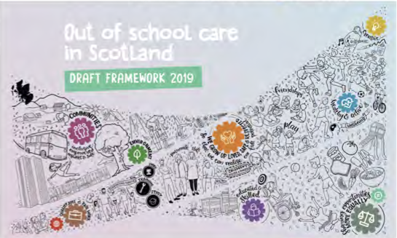
SOSCN is pleased to confirm that the Scottish Government’s OSC team will be joining us at our regional events and that OSC services will have the opportunity to help shape the next development stage of the National Framework for Out of School Care in Scotland.

The Scottish Government is consulting on the recently published draft framework for out of school care and the government’s OSC team would like to hear your thoughts on the questions which form the basis of the consultation.

The draft framework on Out of School Care sets out what the government knows about the out of school care sector in Scotland and asks questions about what the Scottish Government can do to support families in accessing high quality, flexible and affordable services which benefit children and parents and carers.

OSC Draft Framework Consultation:

https://consult.gov.scot/children-and-families/out-of-school-care/
EVENTS  Aberdeen – 30th October (am)  Inverness – 5th November (pm)/ 6th November (am)  Dundee – 8th November (am)  Glasgow – 11th November (am)  Edinburgh – 13th November (am) |  |  |  | DRAFT PROGRAMME  9.30 Registration open and refreshments  10.00 Local & national updates  10.30 Consultation questions discussion  12.30 Close  (A mid-morning break will also be scheduled)
We are delighted to be working in partnership with the following local partners to deliver these events:

OSC FRAMEWORK CONSULTATION EVENTS
BOOKING FORM

Please indicate which event you would like to attend. |  | ‘x’
- Wednesday 30th October morning, ABERDEEN (The Town House)
- Tuesday 5th November evening, INVERNESS (CALA Offices)
- Wednesday 6th November morning, INVERNESS (CALA Offices)
- Friday 8th November morning, DUNDEE (Hilltown Community Centre)
- Monday 11th November morning, GLASGOW (Radisson Blu Hotel)
- Wednesday 13th November morning, EDINBURGH (COSLA Offices)
Delegate one name
Organisation
Contact email address
Contact phone number
Delegate two name
Organisation
Contact email address
Contact phone number
Please note that these events are free of charge and are aimed at lead practitioners/ managers and deputies to attend. Places will be allocated on a first-come-first-served basis although please note that there is much greater capacity at the Edinburgh and Glasgow venues. Further details of venue will be sent once your place has been confirmed. Apart from the Inverness evening event (7 – 9 pm), all events will start at 10am and finish at 12.30pm.
Please return completed booking forms to events@soscn.org or post: SOSCN, Floor 4, 41 St Vincent Place, Glasgow G1 2ER

