SOSCN TRAINING-  AUTUMN SESSIONS 2019 |  | 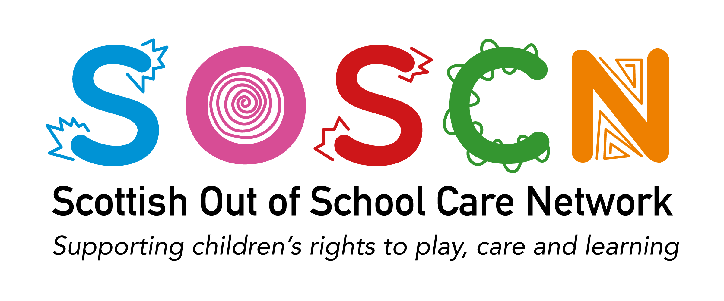
“Getting It Right For Every Child (GIRFEC) & the SHANARRI Wellbeing Indicators in Practice”
“Probably the most useful GIRFEC training I have attended!!”  “We really enjoyed the training and have been reflecting with staff this week on the many things they want to develop and push forward with. We found the training very good and just what we wanted. It covered lots of things that are relevant to us.” | 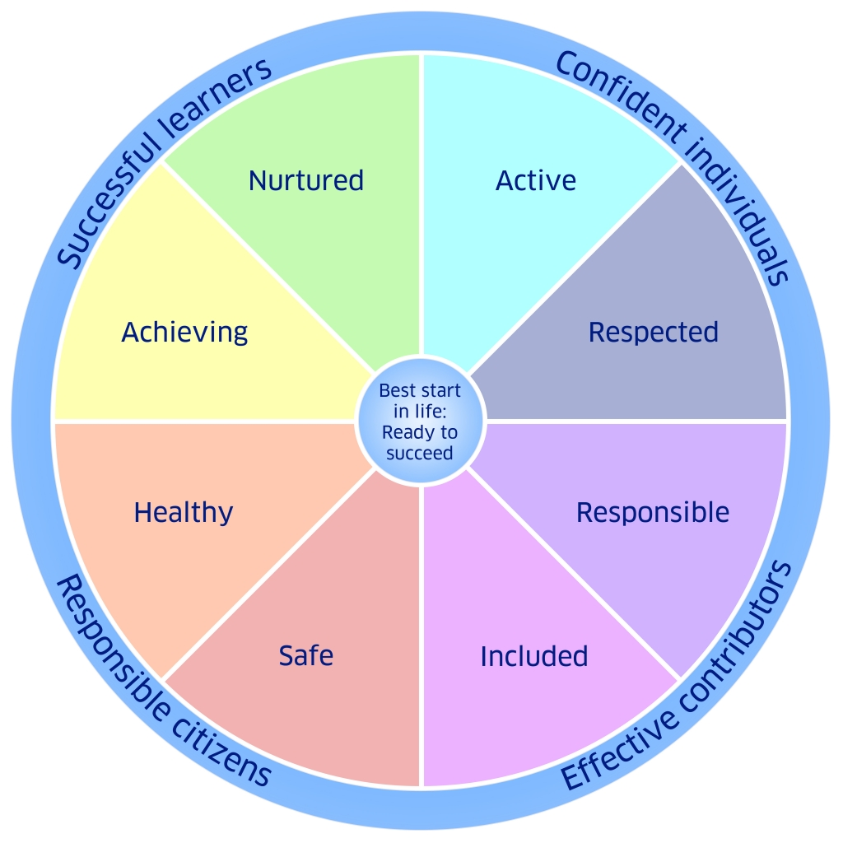
TRAINING VENUES, DATES & TIMES *Glasgow 19^{th,} 5th, & Edinburgh 27th Nov Fully booked*
Dundee Monday 25th November 10.30am – 12.30pm DCA
Irvine Friday 29th November 10.30am – 12.30pm Harbour Arts Centre
Edinburgh Wednesday 27th November 10am – 12pm Central Methodist Church
COST: £40 PER PERSON
Wellbeing and the associated SHANARRI (Safe, Healthy, Achieving, Nurtured, Respected, Responsible, Included) indicators are central to the Getting It Right For Every Child (GIRFEC) approach- they are also key to evidencing the positive impact and outcomes on children and families using out of school care services. The Care Inspectorate expect services to be able to demonstrate how they ensure children’s wellbeing is met.
AIMS OF THE TRAINING SESSION
By the end of the session participants will have a clear understanding of what wellbeing is and how they can achieve better outcomes for the children in their care using reflexive practice based upon the SHANARRI wellbeing indicators, and how to evidence this.
COURSE DESCRIPTOR
This training session will look at how to successfully implement the SHANARRI wellbeing indicators within daily out of school care practice, and how to evidence this, including the creation of children’s personal development plans, as well as service quality improvement and development plans. We shall look at each wellbeing indicator and what this means in terms of developing good practice, how this relates to the UNCRC and also signpost to additional resources.
/BOOKING FORM OVERLEAF
GIRFEC TRAINING
BOOKING FORM

Please indicate which training session you would like to attend. |  |  |  |  |  |  | ‘x’
Glasgow Thursday 5th December 10am – 12pm Albany Centre
Dundee Monday 25th November 10.30am – 12.30pm DCA
Edinburgh Thursday 12th December 10am – 12pm Central Methodist Church
Irvine Friday 29th November 10.30am – 12.30pm Harbour Arts Centre
Organisation
Address
Telephone number
Email address
Invoicing - please use the above details to send the invoice
Invoicing – please use the following details to send the invoice
Alternative invoice details (please include email address):
Participant name
Contact email address
Contact phone number
Participant name
Contact email address
Contact phone number
Participant name
Contact email address
Contact phone number
If you wish to book more than three places, please use an additional booking form.
Total number of participants |  |  | x £40 = Total cost | £
PLEASE NOTE: Services will be invoiced by email and full payment will be expected prior to the training session. Full venue details will be sent on confirmation of booking.
Please return completed booking forms to training@soscn.org or post: SOSCN, Floor 4, 41 St Vincent Place, Glasgow G1 2ER

